MARYLEE G. FAIRBANKS

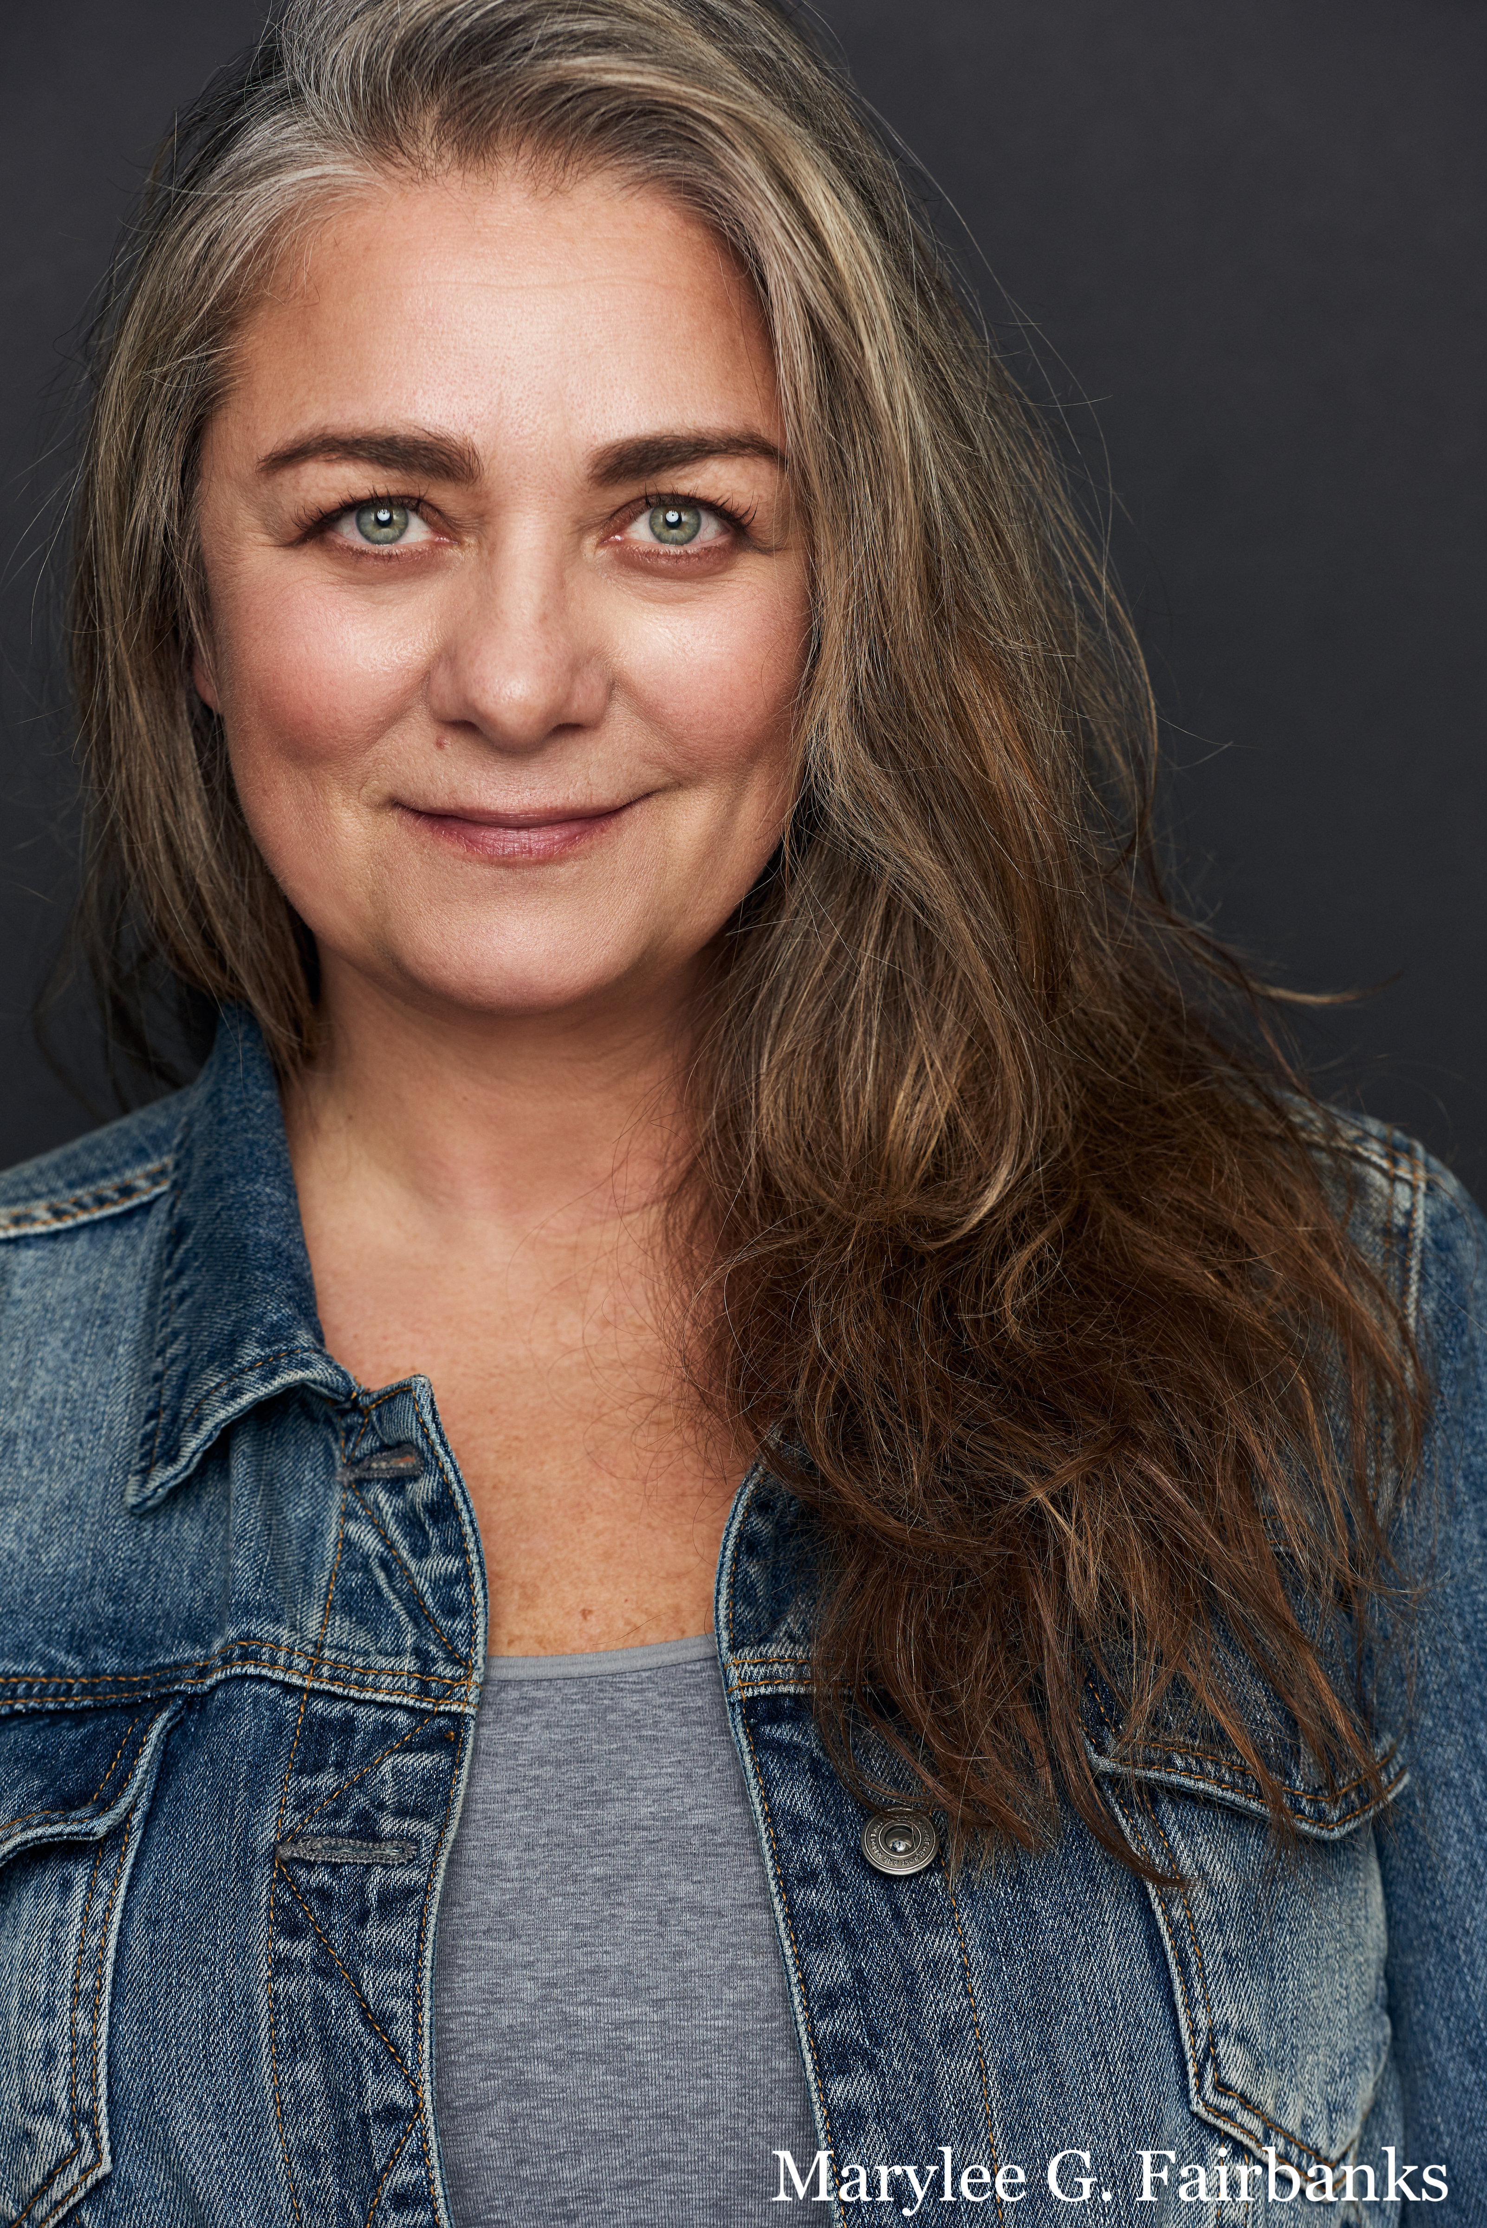
SAG/AFTRA AEA
Mezzo-Soprano (978) 500-4885
Height: 5’ 7” ml@maryleefairbanks.com
Hair: Grey/brown www.stagespodcast.net
Eyes: Green www.maryleegfairbanks.com

Off-BROADWAY
I LOVE YOU YOU’RE PERFECT NOW CHANGE Woman #2 Westside Theatre
New York & Boston Companies

NATIONAL TOURS
RAGTIME Mother (Perf./US) Livent
US PREMIER L.A/Vancouver
THE WILL ROGERS FOLLIES Betty Blake Troika

REGIONAL THEATER
THE MUSIC MAN Mrs. Paroo Reagle Music Theatre
THE THING ABOUT MEN Lucy Am. Stage NY/Broward Ctr
COMPANY Jenny Barrington Stage Co.
JACQUES BREL.... Principle Syracuse Stage
JOHN & JEN Jen Adirondack Festival
THE WILL ROGERS FOLLIES Betty Blake Westbury Music
THE WILL ROGERS FOLLIES Betty Blake Maltz Jupiter Theater
GUYS AND DOLLS Sarah Brown Westchester B'way Theater
MARCH OF THE FALSETTOS Trina Boston Baked Theater

VOICE OVER/ RECORDINGS/COMMERCIAL
Co-Producer and Co-Host of STAGES PODCAST. Partnership with iHeart Radio
www.stagespodcast.net

Voice over/Commercial see website www.maryleegfairbanks.com
A New Stage : Available on Itunes, Amazon
Broadway Inspirations: Varese Sarabande

EDUCATION
1988 EMERSON COLLEGE BS (Mass Communication/Theater Arts)

SPECIAL SKILLS
Founder Chakras Yoga Company, yoga teacher
Writer Elephant Journal, LA & Boston Yoga Magazine, Gaiam, Bliss (see website for publications)
Founder TIMA PRODUCTIONS (Kimberly Akimbo)
Accents: Boston, New York dialects, Irish Brogue

